**WORKING WITH VAGRANT**

1. Install a Virtual Box

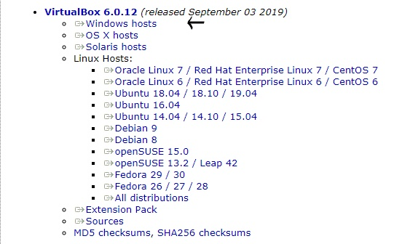

1. Install Vagrant

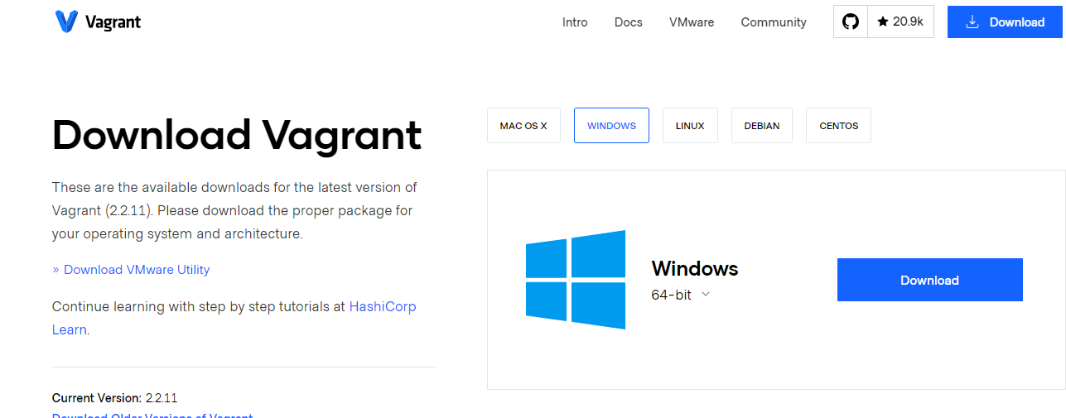

1. Open command prompt and make a folder “VM_Lab”. Change into that folder and execute a command “vagrant init”
2. A “Vagrantfile” will be created and make the following change

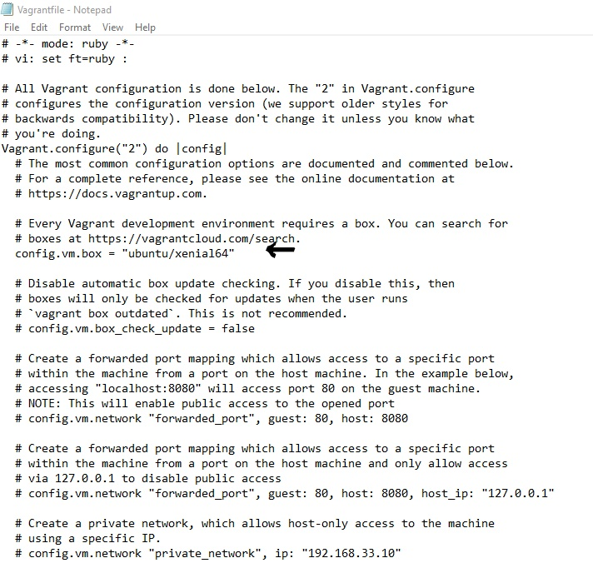

1. Now run a command “vagrant up” to execute the changes made in vagrantfile

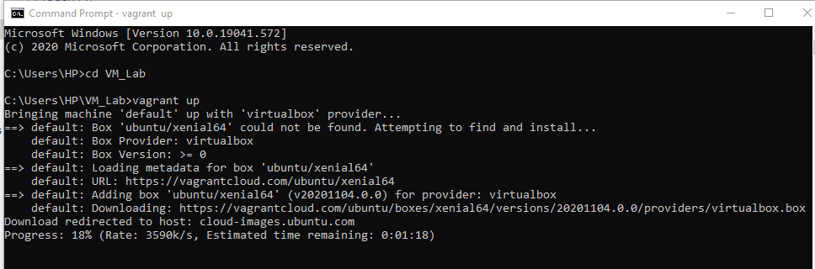

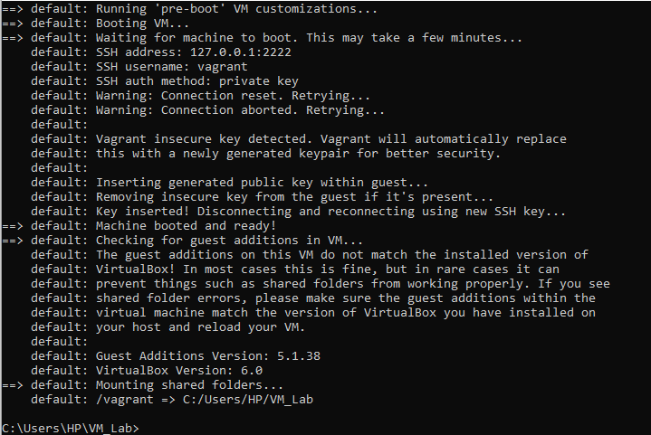

1. Now execute another command “vagrant ssh” to go into that ubuntu machine

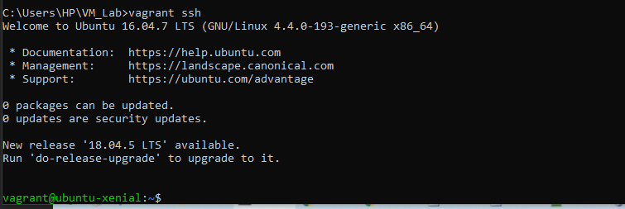

ATISHAY JAIN

500067694

R171218030

CSE, DEVOPS